Ideation Phase
Brainstorm & Idea Prioritization Template

Date | 10 FEB 2026
Team ID | LTVIP2026TMIDS24974
Project Name | Toycraft Tales: Tableau's Vision into Toy Manufacturer Data
Maximum Marks | 4 Marks

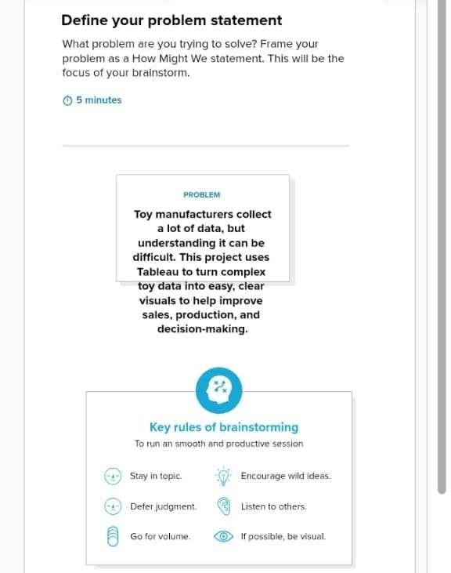
Brainstorm & Idea Prioritization Template:
Brainstorming creates an open and supportive atmosphere where team members can freely share ideas and contribute to creative problem-solving. The focus is on generating as many ideas as possible, encouraging innovative thinking without immediate judgment. Participants collaborate by building on each other’s suggestions, which helps produce a wide range of potential solutions.
This template can be used to organize brainstorming sessions effectively, allowing teams to exchange thoughts, develop concepts, and refine ideas even when they are working remotely rather than in the same physical space.
Reference: https://www.mural.co/templates/brainstorm-and-idea-prioritization
Step-1: Team Gathering, Collaboration and Select the Problem Statement

Step-2: Brainstorm, Idea Listing and Grouping
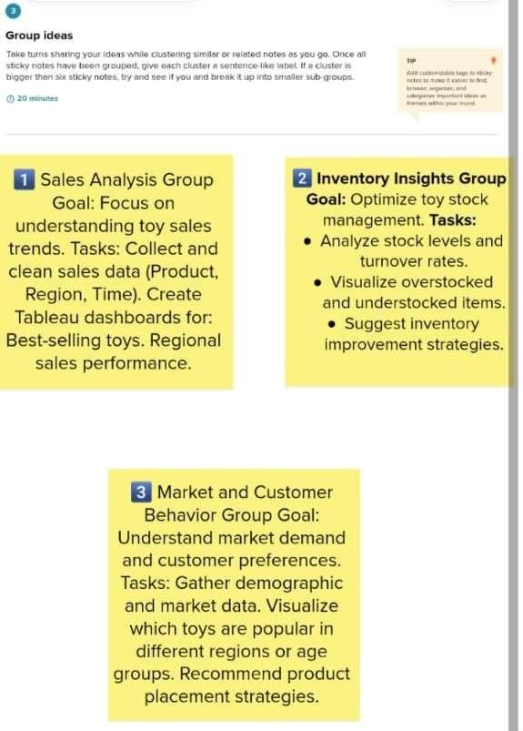
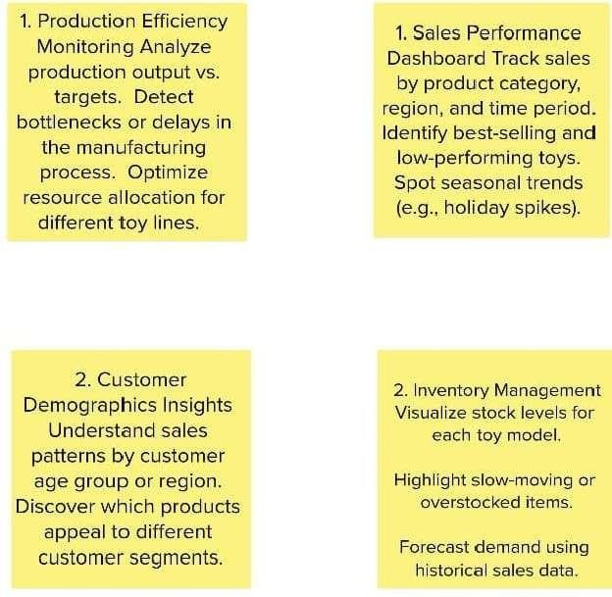

Step-3: Idea Prioritization

